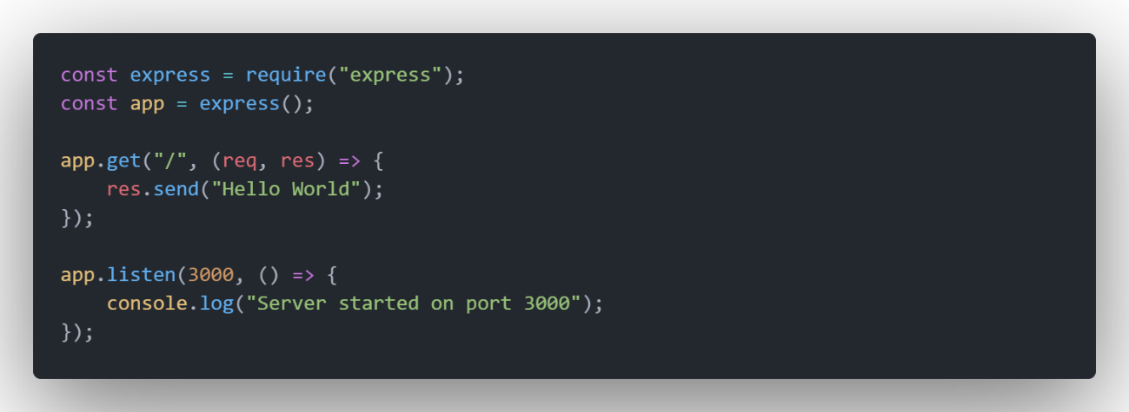

## Código

const express = require("express");

const app = express();

app.get("/", (req, res) => {

    res.send("Hello World");

});

app.listen(3000, () => {

    console.log("Server started on port 3000");

});